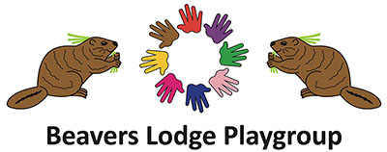

Our Term dates 2026-2027

Term 1 - Autumn 2026
- Wednesday 2 September to Friday 11 December 2026 = 14 weeks
- Half term: Monday 26 October to Friday 30 October 2026
Term 2 - Spring 2027
- Monday 4 January to Thursday 25 March 2027 = 11 weeks
- Half term: Monday 15 February to Friday 19 February 2027
Term 3 - Summer 2027
- Monday 12 April to Thursday 16 July 2027 = 13 weeks
- Half term: Monday 31 May to Friday 4 June 2027
- Bank holiday: Monday 3 May 2027

